Assignment-2

1 Reverse a Number: Write a program that takes an integer as input and outputs the reverse of that number.

n = int(input("Enter the number: "))
rev_num = 0
while n!=0:
rem = n%10
rev_num = rev_num*10+rem
n = n//10
print(rev_num)
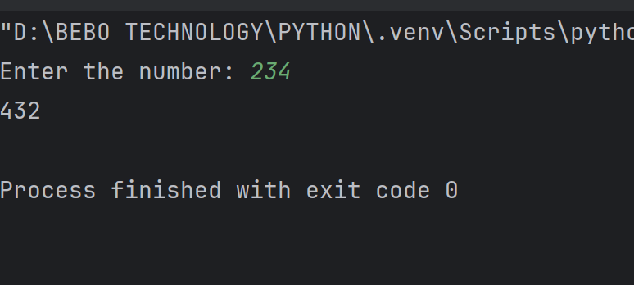

2 Find Factorial: Create a function that accepts a positive integer n and calculates the factorial of n using a loop.

n = int(input("Enter the number: "))
fact = 1
for i in range(1,n+1):
fact*=i
print(fact)
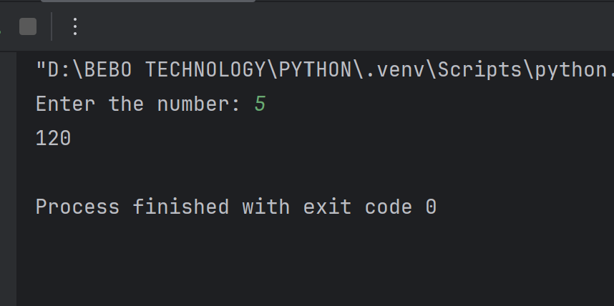

3 Leap Year Checker: Create a function that takes a year as input and determines if it's a leap year. A year is a leap year if:

year = int(input("Enter the Year:"))
if(year%400==0):
print("Leap Year")
elif(year%100==0):
print("Not a Leap Year")
elif(year%4==0):
print("Leap Year")
else:
print("Not a Leap year")
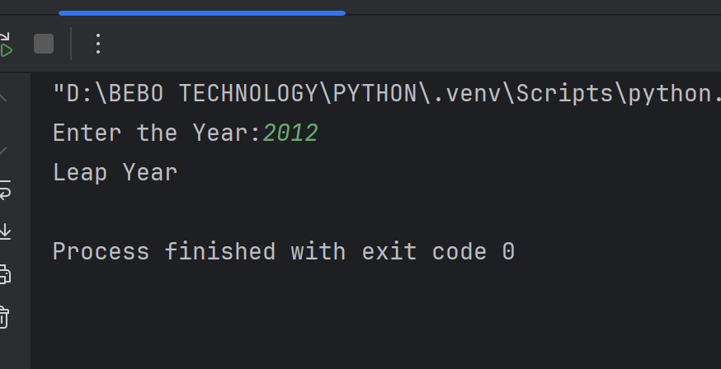
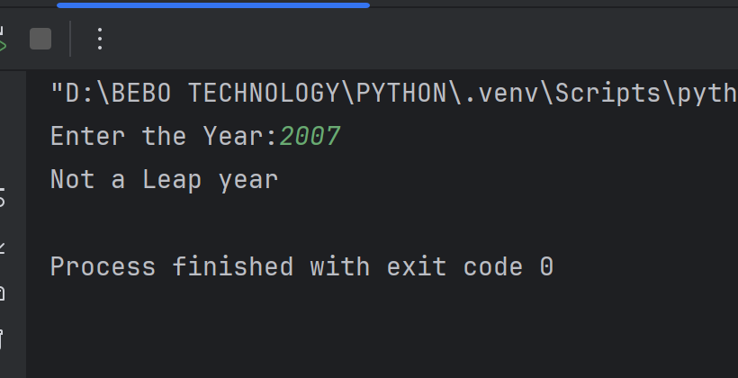

4 Calculate Power: Write a function that takes two integers, base and exponent, and calculates the power of base raised to exponent using a loop. Do not use Pythonâ€™s built-in power function.

base = int(input("Enter the base:"))
power = int(input("Enter the Power"))
result = 1
for i in range(power):
result*=base
print(result)
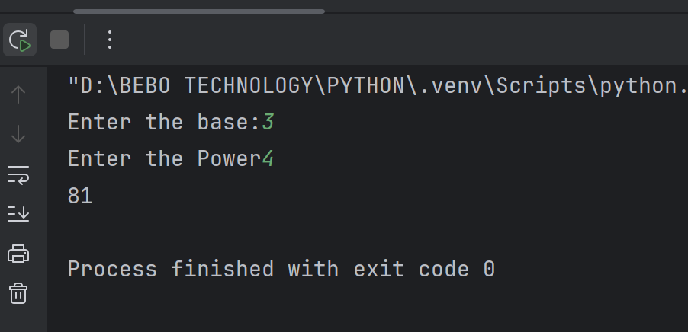

5 Sum of Even Numbers: Create a program that accepts a positive integer n and calculates the sum of all even numbers from 1 to n. For example, if n is 10, the output should be 30 (2 + 4 + 6 + 8 + 10).

n = int(input("Enter the number: "))
sum = 0
for i in range(1,n+1):
if(i%2==0):
sum+=i
print(sum)
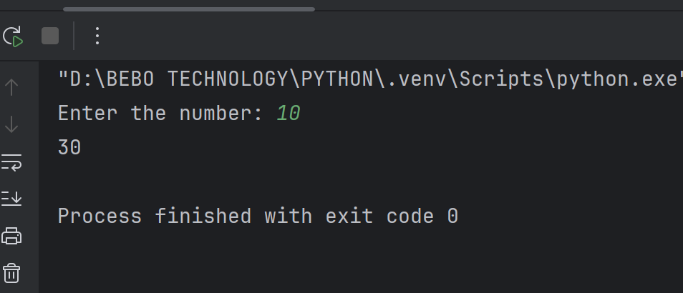

6 Sum of Digits Until Single Digit: Create a function that takes an integer as input and repeatedly finds the sum of its digits until a single-digit number is obtained. For example, if the input is 9875, the output should be 2 (9+8+7+5=29 -> 2+9=11 -> 1+1=2).

def sum_of_digit(n):
while n >= 10:
sum_digits = 0
while n > 0:
rem = n % 10
sum_digits += rem
n //= 10
n = sum_digits
return n
# Get input from the user
n = int(input("Enter the number:"))
result = sum_of_digit(n)
print("The single-digit result is:", result)
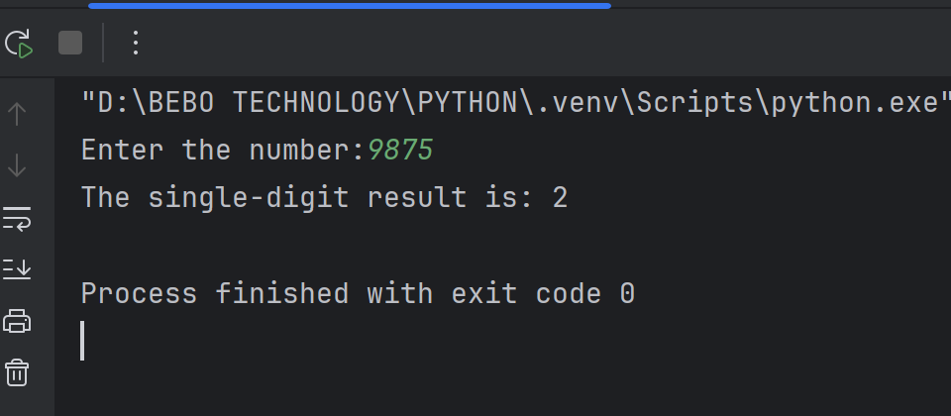

7 Login Authentication: Write a program that accepts a username and password from the user and checks if they match the pre-set username and password. If both match, print "Access Granted"; otherwise, print "Access Denied."

_username = "aman321"
_password = "1234"
username = input("Enter the username: ")
password = input("Enter the password: ")
if(username == _username and password == _password):
print("Access Granted")
else:
print("Access Denied")

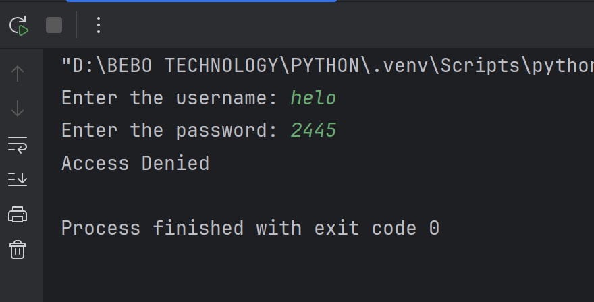
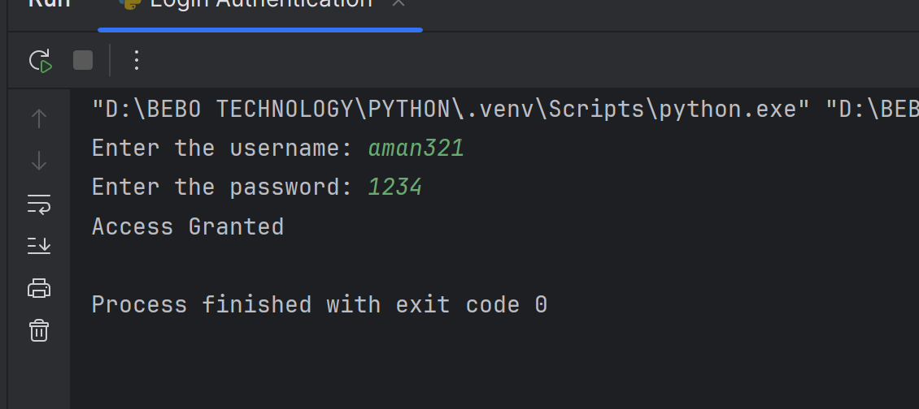

8 Movie Ticket Pricing: Write a function that determines the ticket price based on the age of a person. If the person is under 12 years old, the price is $5. If the person is between 12 and 64, the price is $12. If the person is 65 or older, the price is $7. Return the ticket price as an integer.

def movie_ticket_pricing(age):
if age < 12:
return 5
elif 12 <= age <= 64:
return 12
else:
return 7
age = int(input("Enter the age: "))
result = movie_ticket_pricing(age)
print(f"Price: ${result}")
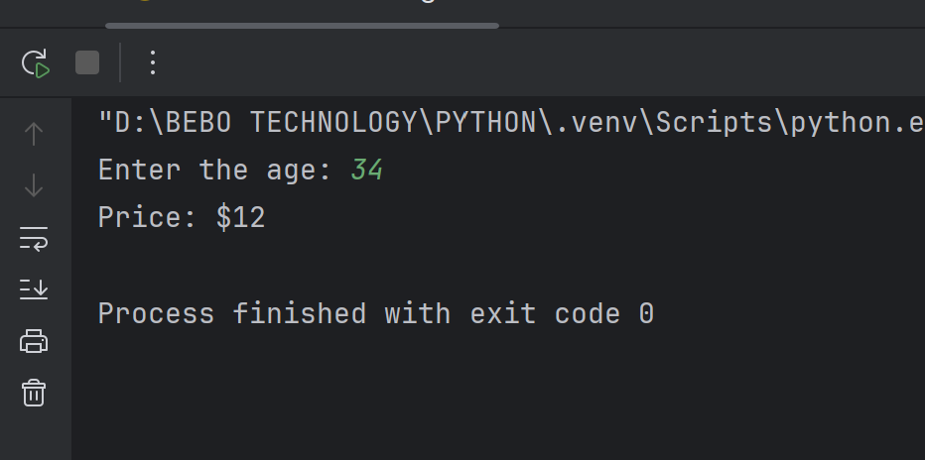

9 Ride Height Requirement: Youâ€™re managing a theme park ride. To go on the ride, a person must be at least 48 inches tall. However, if theyâ€™re between 42 and 47 inches, they can ride if accompanied by an adult. If they are under 42 inches, they cannot ride at all. Write a function that takes in the height and a boolean for whether an adult is present, and returns True if they can ride, False otherwise.

def can_ride(height, has_adult):
if height>=48:
return True
elif 42<=height<48 and has_adult:
return True
else:
return False
height = int(input("Enter the height: "))
has_adult = input("Is there an adult present? (yes/no): ").lower()=="yes"
result = can_ride(height,has_adult)
print(result)
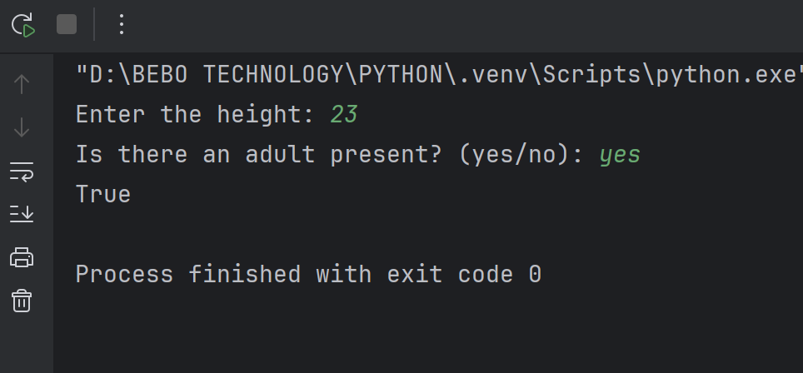
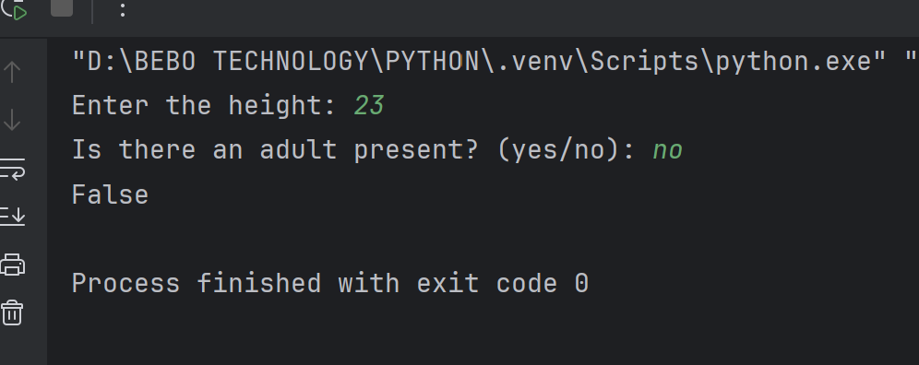

Q.10 Festival Ticket: A festival has different ticket prices based on age and time of day. If the person is 18 or younger, the ticket costs $10. If theyâ€™re between 19 and 59, itâ€™s $20. For those aged 60 and above, itâ€™s $15. However, after 8 pm, all tickets are discounted by 50%. Write a function that takes in age and time (in 24-hour format) and returns the ticket price after any applicable discounts.

def festival_ticket_price(age, time):
if age <= 18:
price = 10
elif 19 <= age <= 59:
price = 20
else:
price = 15
if time >= 20:
price /= 2
return price
age = int(input("Enter your age: "))
time = int(input("Enter the time (24-hour format): "))
ticket_price = festival_ticket_price(age, time)
print(f"Ticket price: ${ticket_price:.2f}")
